
Press Release no. 9

TTG 2023, THE “VISION” OF TOURISM OF THE FUTURE IS SUPERNATURAL

- «Origins of Creation, SYNCRETIC (A)Identities, RITUALS & RULES, BE Life-ADAPTIVE, ONLY HUMAN?»: the five new Deep Trends™ for tourism industry professionals featured at the Italian Exhibition Group event held at Rimini Expo Centre

- In the AI era, the challenge is to retrieve the characteristics of the human experience

www.ttgexpo.it - www.inoutexpo.it
#ttgexpo - #INOUTexpo - #IEGexpo

Rimini, 12 October 2023 – «A new changing cultural dimension». TTG Travel Experience, the tourism marketplace organized by Italian Exhibition Group at the Rimini Expo Centre from October 11-13, presents Vision +24.
A 3-day event with over 200 appointments, Vision TTG is without a doubt the industry’s hub for future tourism, inspiring trade professionals and promoting the evolution of the travel industry, rolling out the most significant innovations and consumer trends worldwide.

We’re living at the hinge of history, when new technologies are opening up unexpected possibilities for sorting and interpreting the complex flow of information that define our here and now, guaranteeing the option of greater predictive control over both nature and life. AI promises to map out whatever exists, bestowing unprecedented power on human beings. At the same time, however, we are witnessing the emergence of a need closely connected to the mystical and religious realm, a pairing that gives life to a new changing cultural dimension. «SUPERNATURAL» is today’s way of interpreting the present, influencing brands in their creation of products and services, selling sites, and the rationale behind accessibility to travel destinations.

Trends gaining momentum include packages allowing travellers to come into direct contact with artists, designers, musicians, artisans and spiritual guides, encouraging new ways of cultural contamination. The world of transport is progressively investing services that take care of the passenger as part of an ecosystem to be preserved, through new alliances between land-air vehicles, the optimization of routes, hydroponic crops on board cruise ships, the choice of fuel, the adaptation of infrastructure to new energy saving needs. Hotel companies are adopting building and interior design standards that foster sustainability, advocate local artisans and materials, incorporate and enhance greenery in their internal spaces. They are committed to reducing food waste, energy saving, reducing CO2 immisions, and growing zero-miles produce in their gardens and terraces. The real challenge is knowing how to retrieve the characteristics of human experience by quickly adapting to changing contexts. Themes that become case studies for trade professionals at the TTG Travel Experience, in the presentation of the five Deep Trends™ for 2024: Origins of Creation, SYNCRETIC (A)Identities, RITUALS & RULES, BE Life-ADAPTIVE, ONLY HUMAN?

ABOUT: TTG TRAVEL EXPERIENCE
Event: international trade show; organizer: Italian Exhibition Group SpA; recurrence: annual; edition: 60th; open to: reserved exclusively for industry professionals; website: www.ttgexpo.it - #ttgexpo

ITALIAN EXHIBITION GROUP PRESS CONTACTS
Head of media relations & corporate communication: Elisabetta Vitali; press office manager: Marco Forcellini; international press office coordinator: Silvia Giorgi: media@iegexpo.it

MEDIA AGENCY: MYPR Lab
Filippo Nani, filippo.nani@myprlab.it; Enrico Bellinelli, enrico.bellinelli@myprlab.it; mob. +39 392 7480967; Francesca Magnanini, francesca.magnanini@myprlab.it; mob. +39 338 6910347

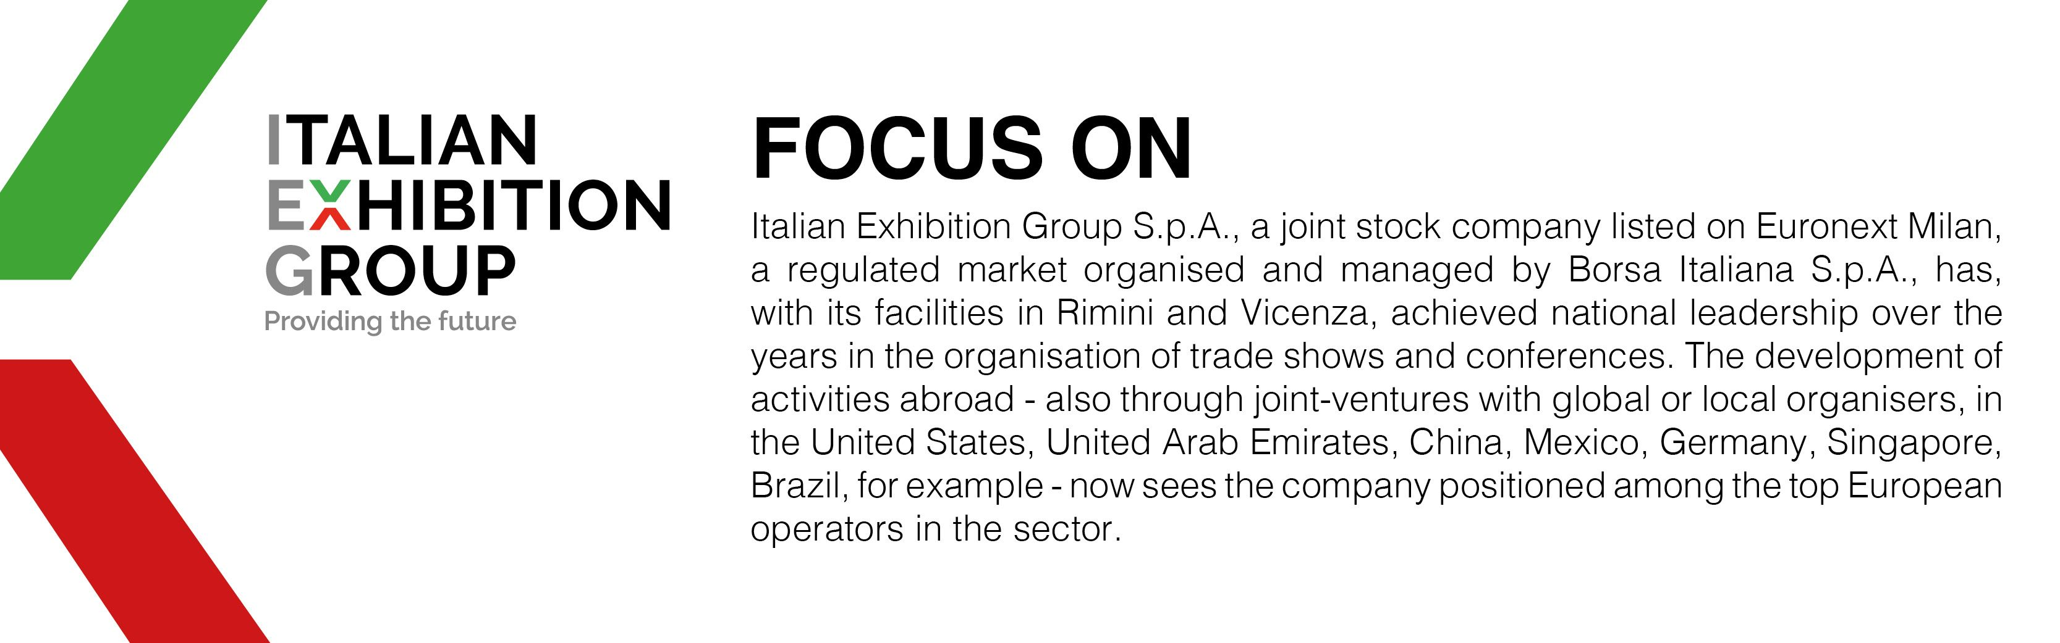

PRESS CONTACT ITALIAN EXHIBITION GROUP
Head of media relation & corporate communication: Elisabetta Vitali; press office manager: Marco Forcellini;
international press office coordinator: Silvia Giorgi; media@iegexpo.it

MEDIA AGENCY TTG Travel Experience 2023: MY PR Lab
Filippo Nani, +39 0444.512550, filippo.nani@myprlab.it; Francesca Magnanini, +39 338 6910347, francesca.magnanini@myprlab.it; Enrico Bellinelli, +39 392 748 0967, enrico.bellinelli@myprlab.it

This press release contains forecast elements and estimates that reflect the management’s current opinions (“forward-looking statements”), particularly regarding future management performance, realization of investments, cash flow trends and the evolution of the financial structure. For their very nature, forward-looking statements have a component of risk and uncertainty, as they depend on the occurrence of future events. The effective results may differ (even significantly) from those announced, due to numerous factors, including, only by way of example: food service market and tourist flow trends in Italy, gold and jewellery market trends, green economy market trends; the evolution of raw material prices; general macroeconomic conditions; geopolitical factors and evolutions in the legislative framework. Moreover, the information contained in this release does not claim to be complete, and has not been verified by independent third parties. Forecasts, estimates and objectives contained herein are based on the information available to the Company as at the date of this release.

